Car Rental System

The Car Rental System simplifies vehicle rentals by allowing customers to book and manage rentals easily. It also helps staff efficiently handle reservations, payments, and vehicle maintenance across multiple branches.

1. **Customers:**

It stores information about **CUSTOMER_ID, EMAIL, FULL_NAME, LICENSE_NUMBER, ADDRESS, CITY, STATE, AGE**

DDL SCRIPT:

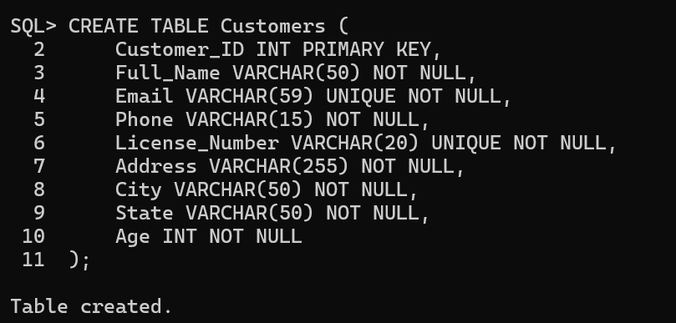

DESCRIBE:

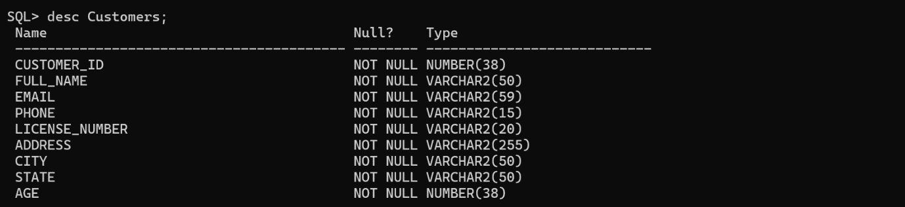

DML SCRIPT:

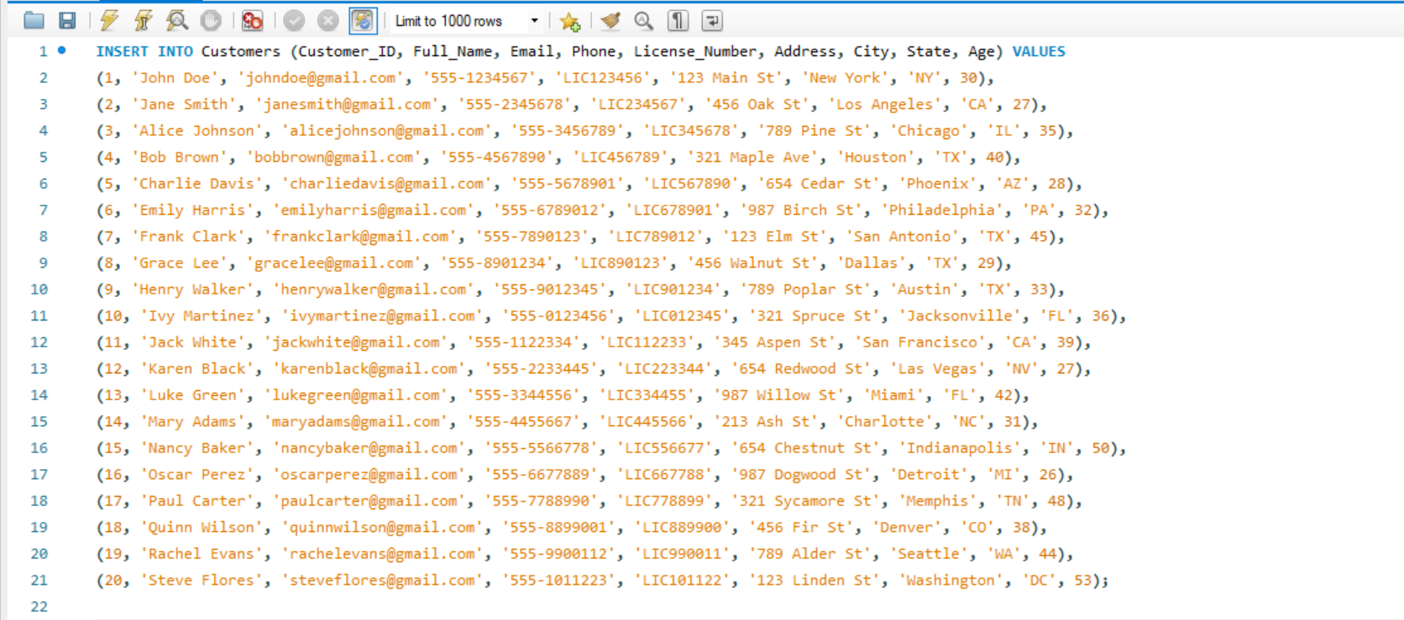

DQL SCRIPT:

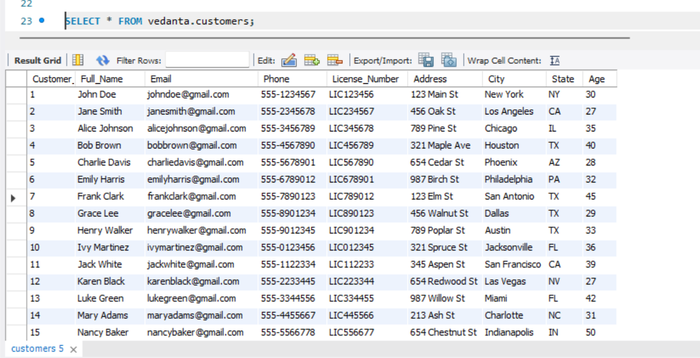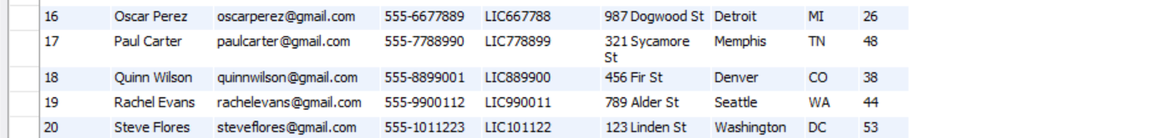

1. **EMPLOYEE:**

It stores information about **EMPLOYEE_ID, EMAIL, FIRST_NAME, LAST_NAME, ADDRESS, CITY, STATE, PHONE**

DDL SCRIPT:

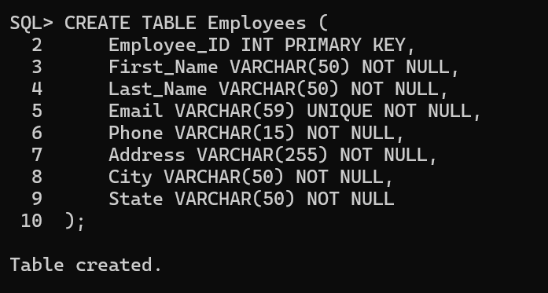

DESCRIBE:

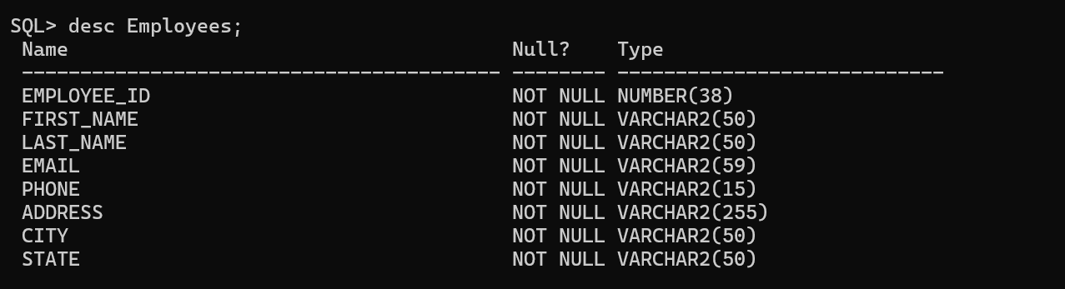

DML SCRIPT:

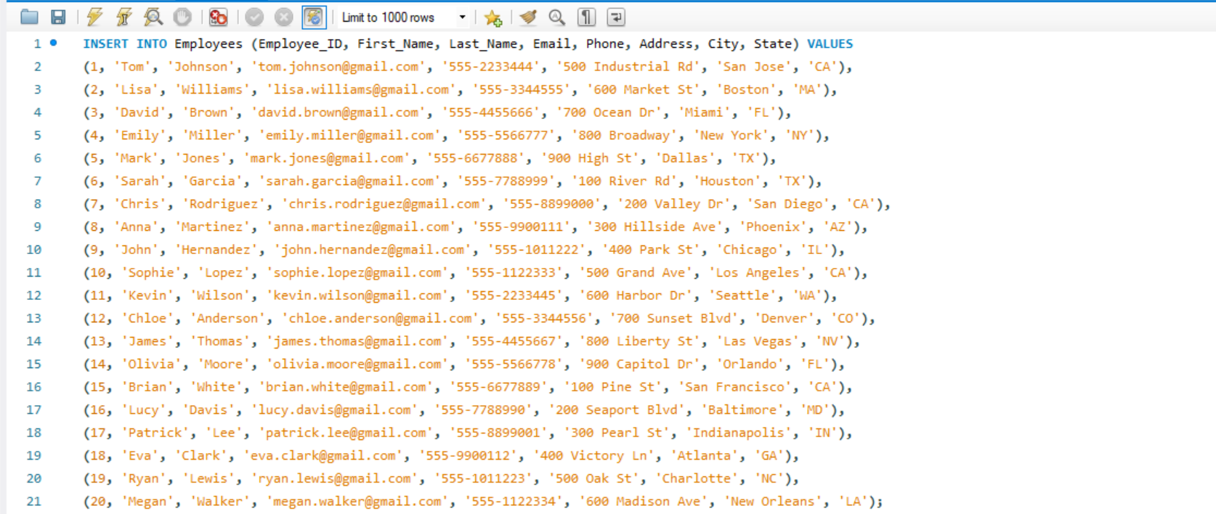

DQL SCRIPT:

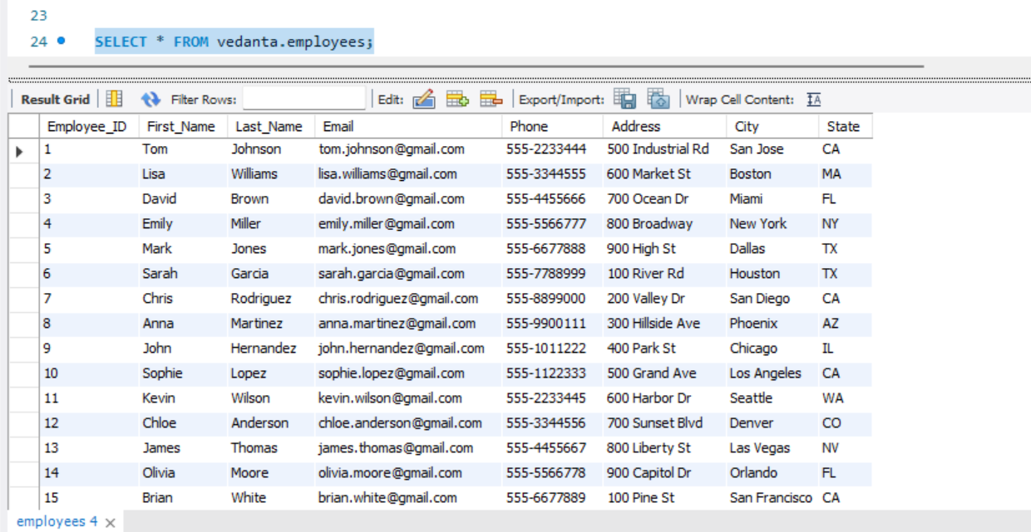

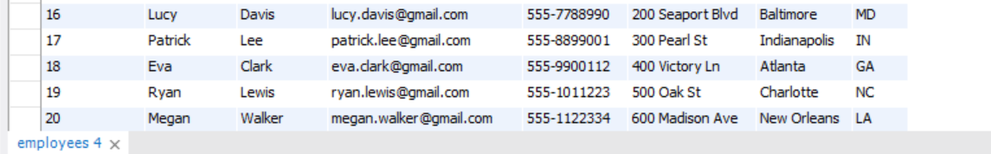

1. **BRANCHES:**

It stores information about **BRANCH_ID, BRANCH_NAME, PHONE, ADDRESS, CITY, STATE**

DDL SCRIPT:

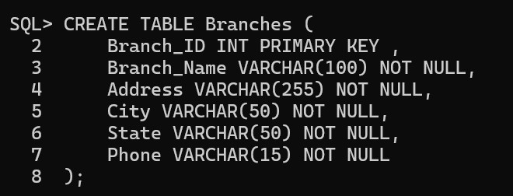

DESCRIBE:

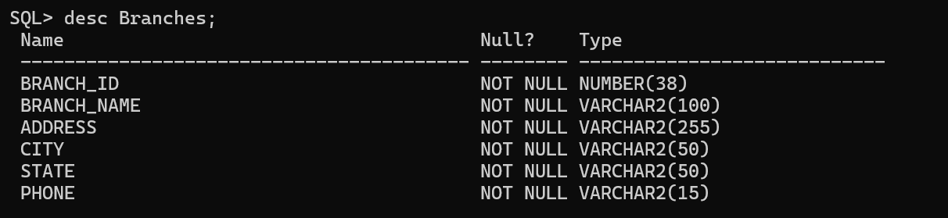

DML SCRIPT:

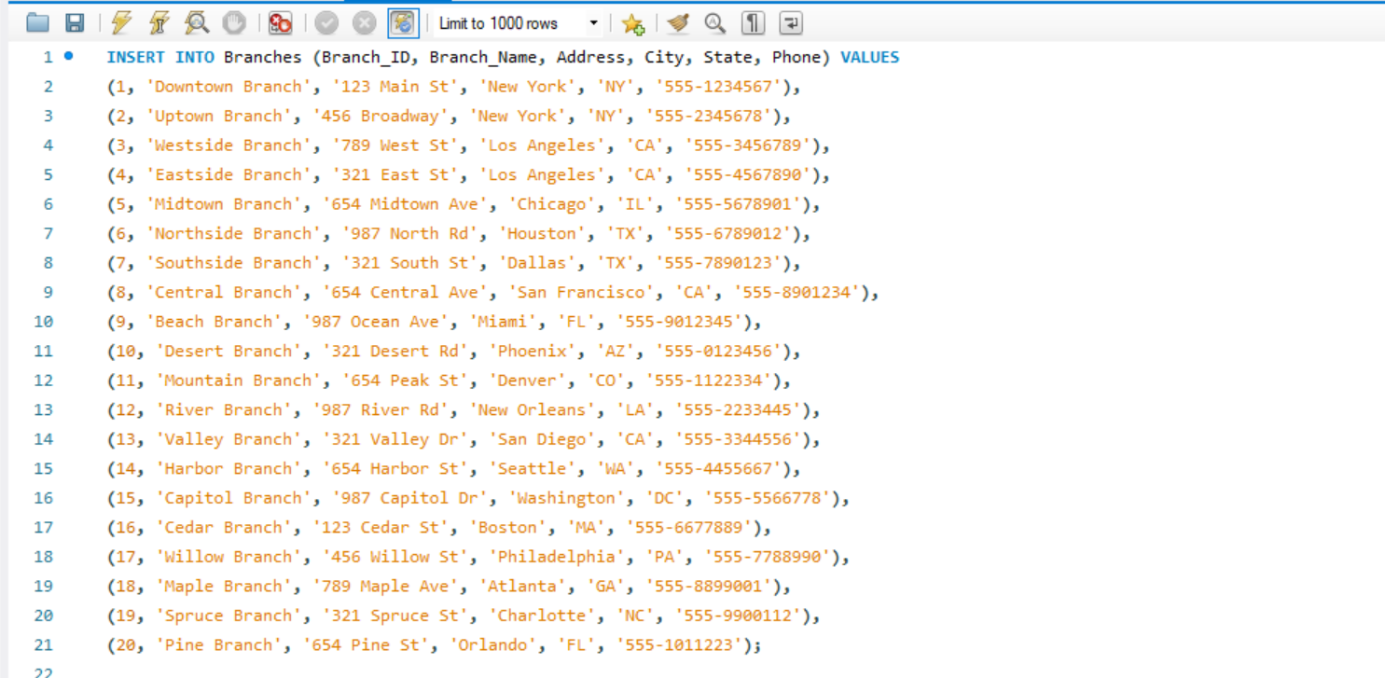

DQL SCRIPT:

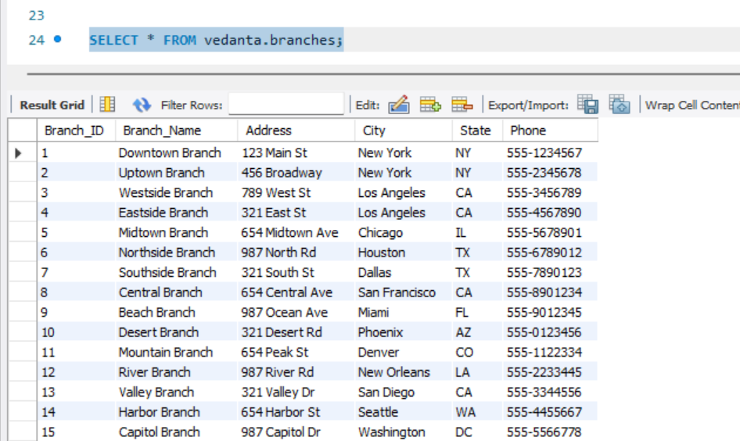 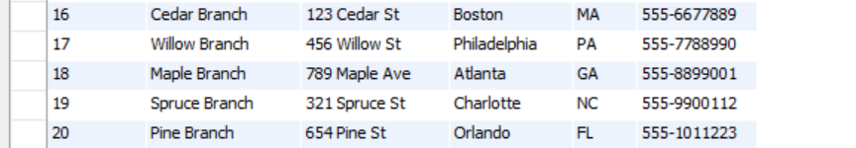

**4. VEHICLES:**

It stores information about **Vehicle_ID, Type_ID, Manufacturar, Model, Year, License_Plate, Color, Current_Mileage, Branch_ID**

DDL SCRIPT:

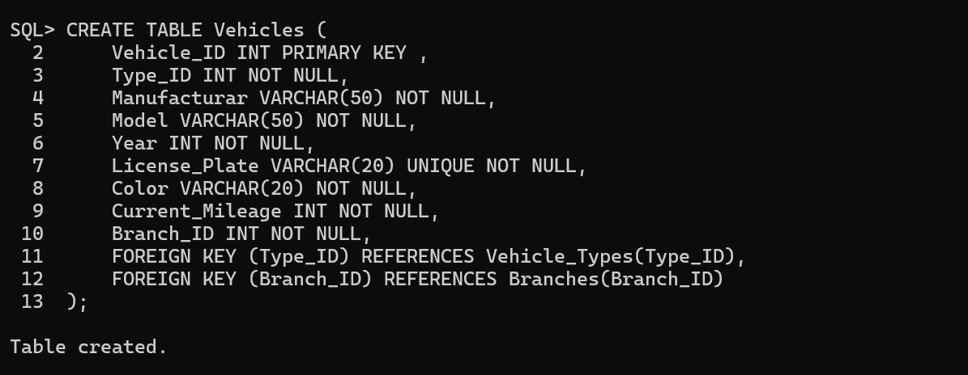

DESCRIBE:

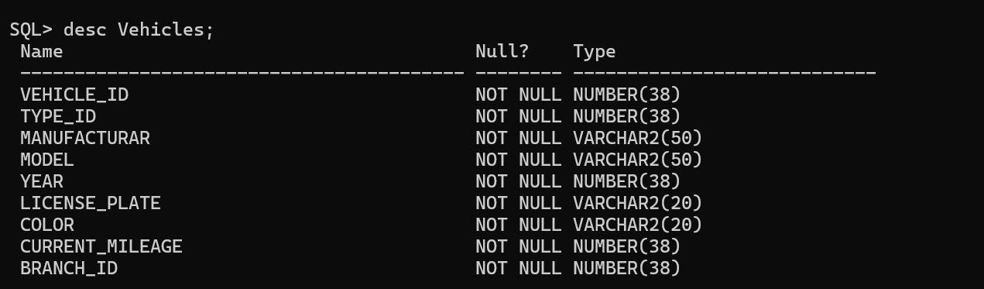

DML SCRIPT:

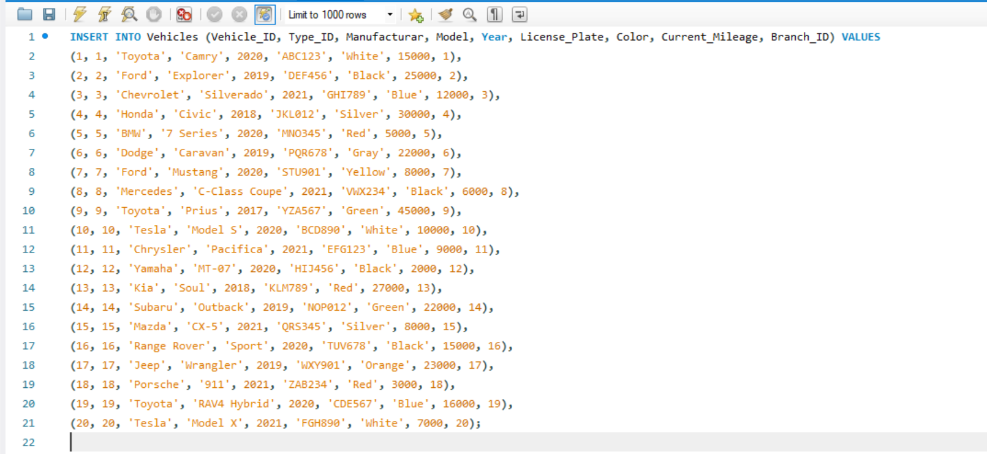

DML SCRIPT:

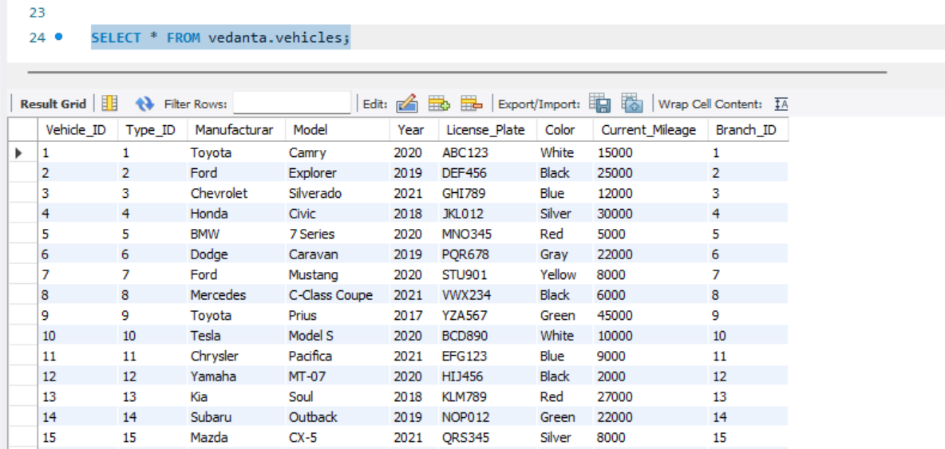

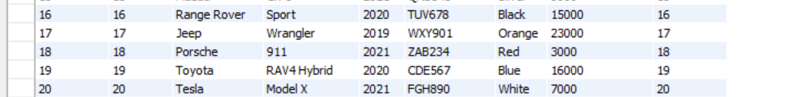

1. **VEHICLE_TYPES:**

It stores information about **Type_ID, Type_Name, Description, Daily_Rate, Weekly_Rate, Monthly_Rate.**

DDL SCRIPT:

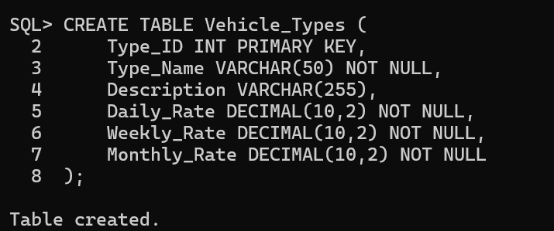

DESCRIBE:

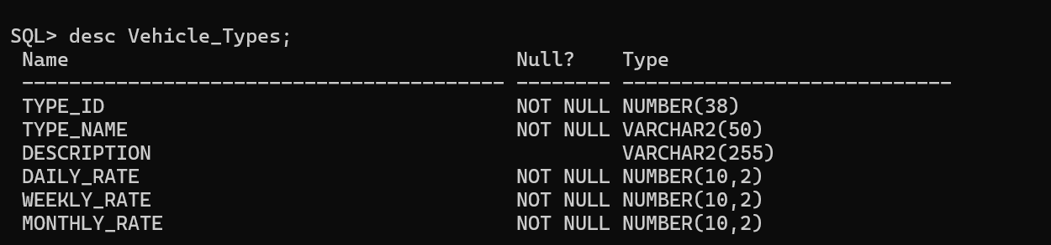

DML SCRIPT:

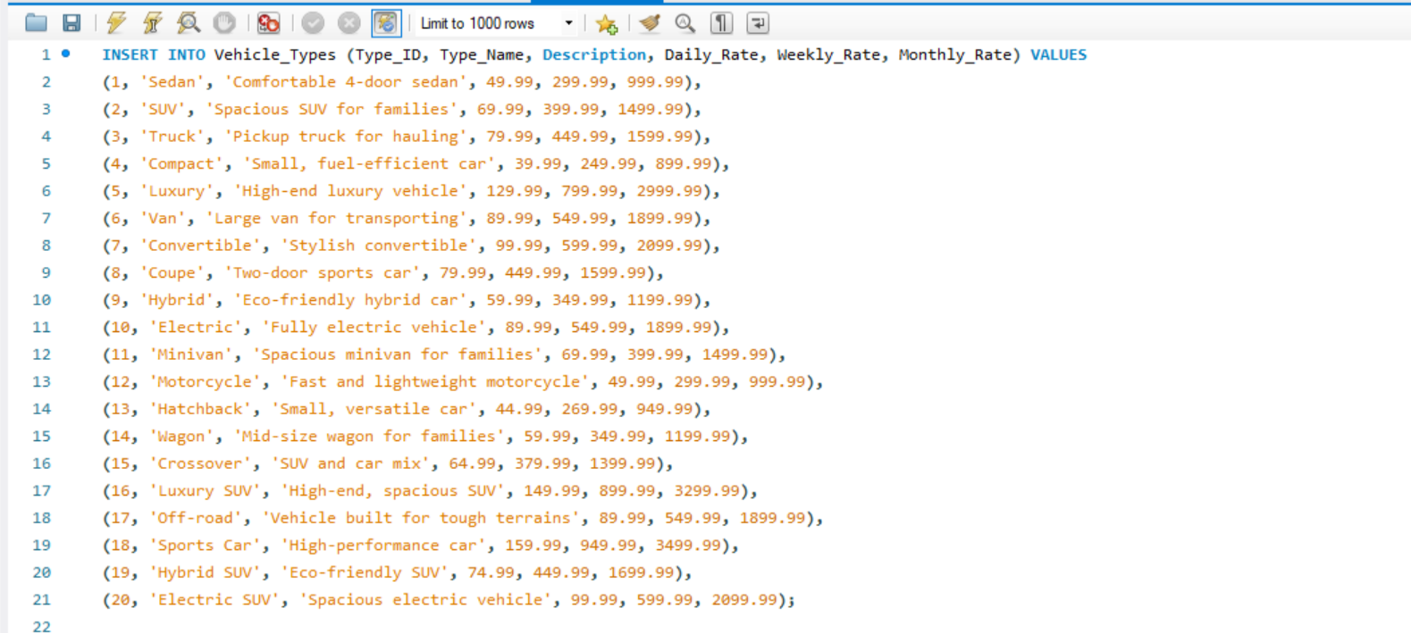

DQL SCRIPT:

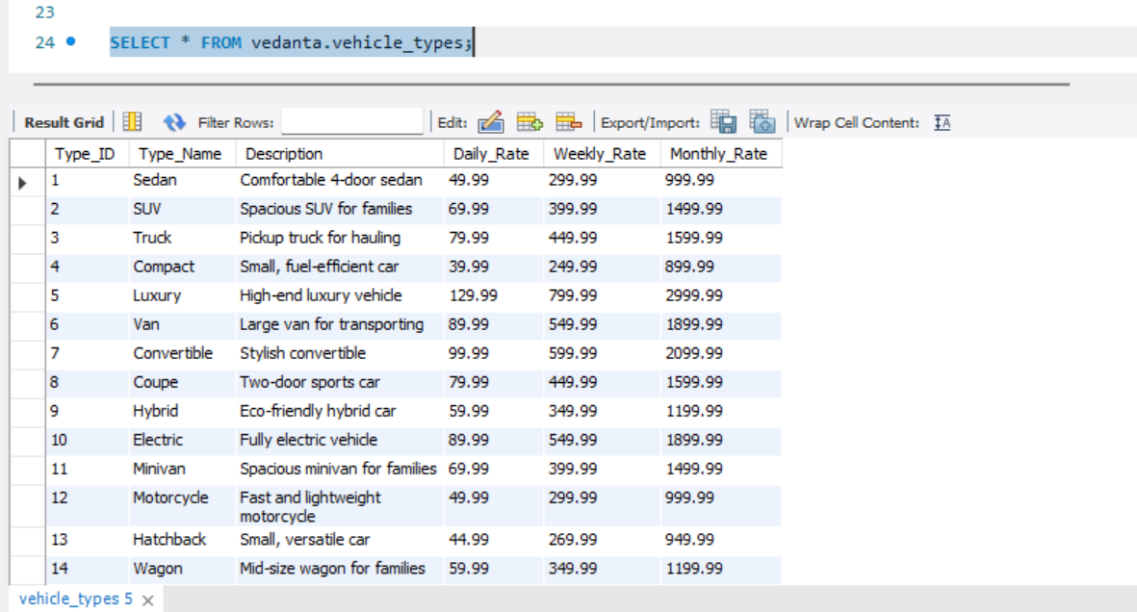

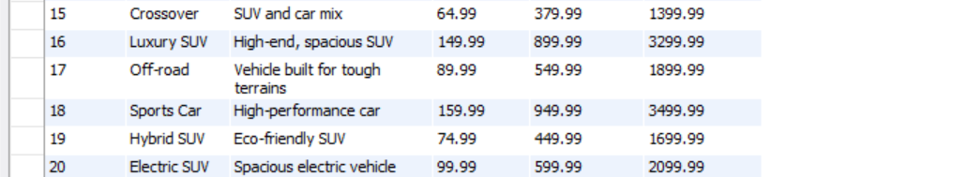

1. **VEHICLE_STATUS:**

It stores information about **Status_ID, Vehicle_ID, Status, and Last_Updated.**

DDL SCRIPT:

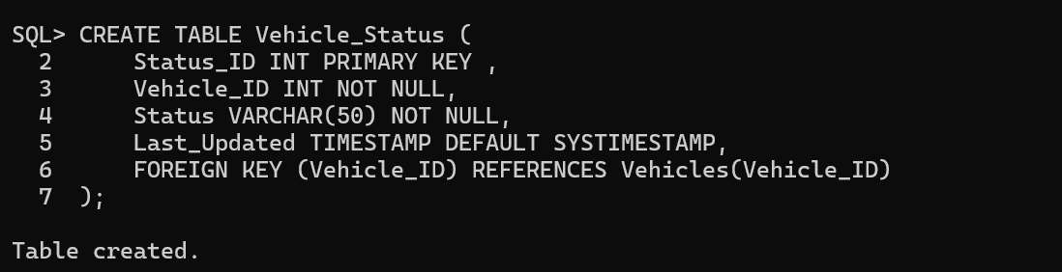

DESCRIBE:

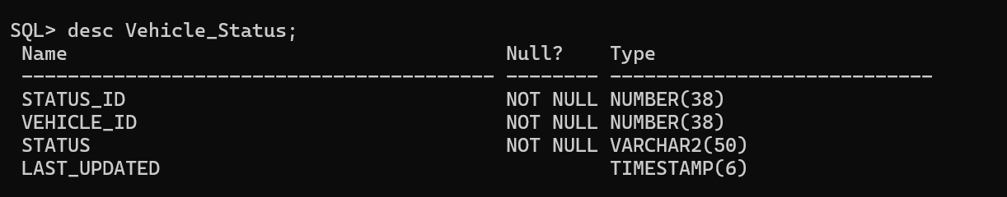

DML SCRIPT:

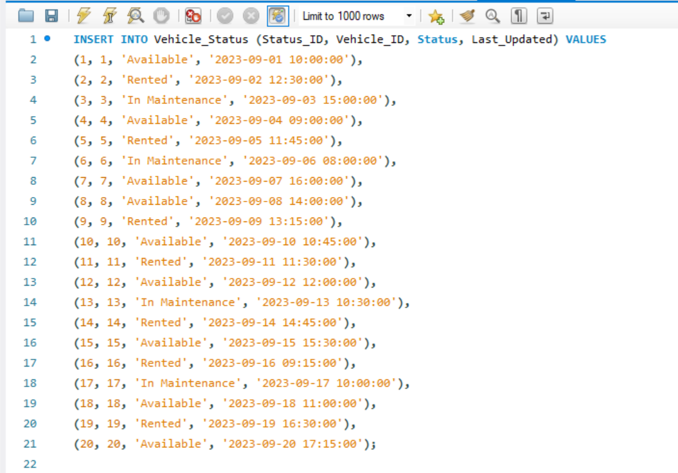

DQL SCRIPT:

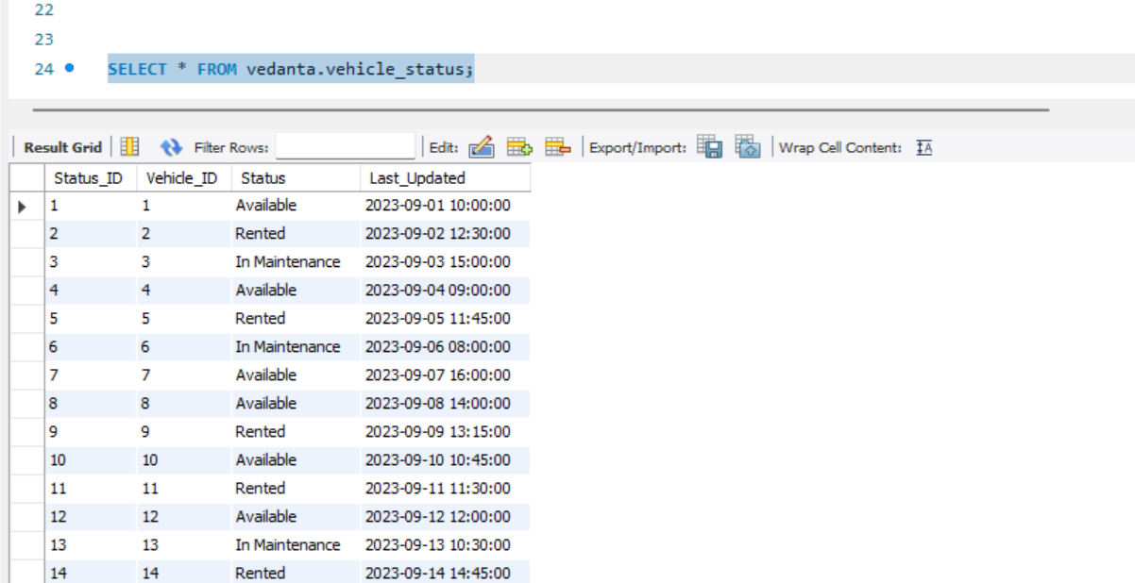

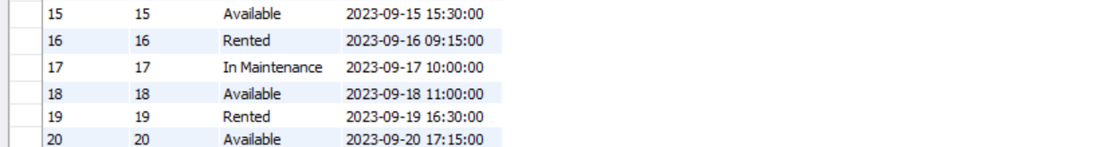

1. **VEHICLE_MAINTANENCE:**

It stores information about **Maintenance_ID, Vehicle_ID, Maintenance_Date, Description, Cost.**

DDL SCRIPT:

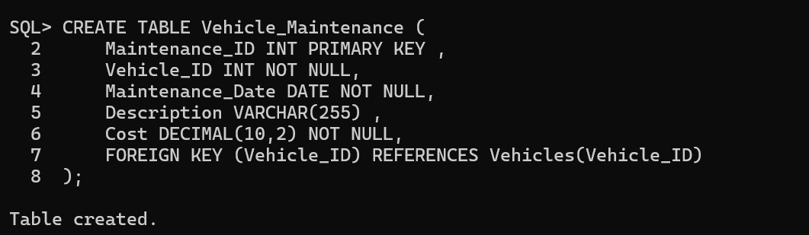

DESCRIBE:

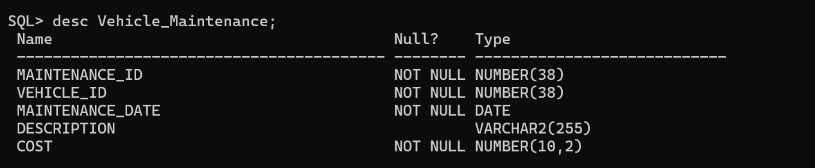

DML SCRIPT:

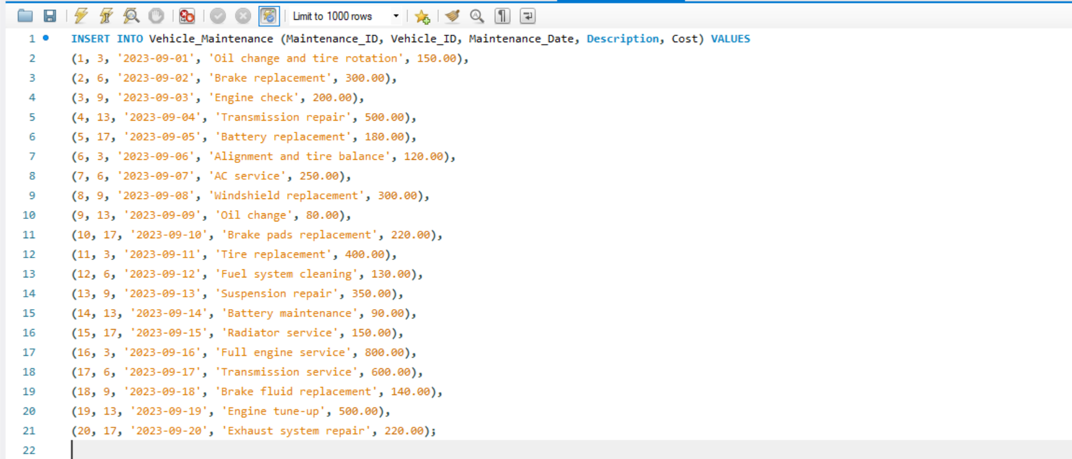

DQL SCRIPT:

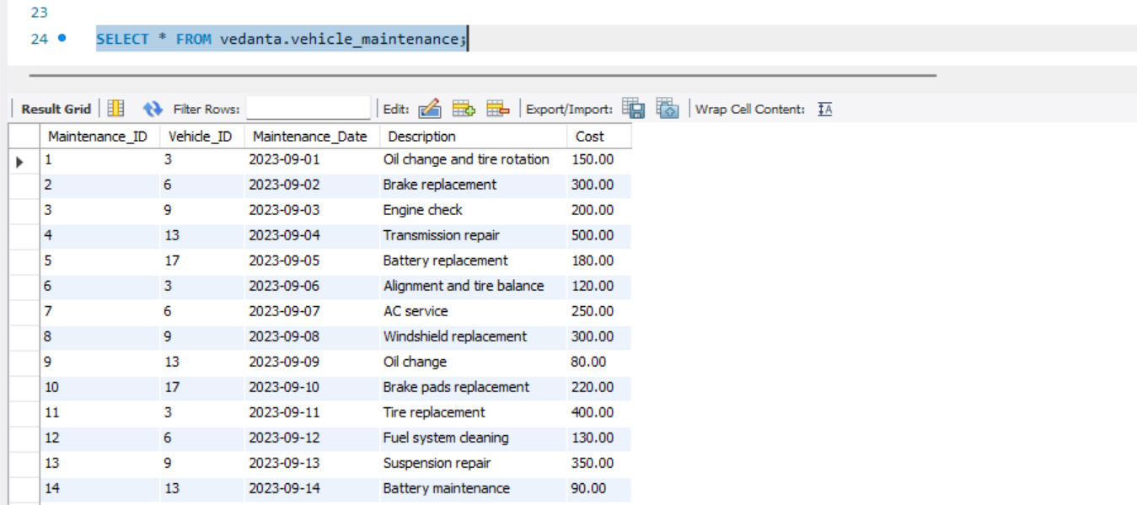

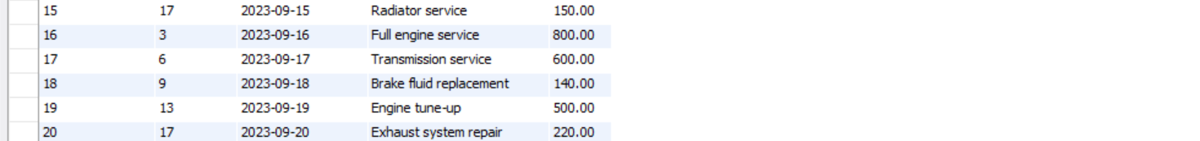

1. **RENTALS:**

It stores information about **Rental_ID, Customer_ID, Vehicle_ID, Employee_ID, Rental_Start_Date, Rental_End_Date, Actual_Return_Date, Pickup_Branch_ID, Dropoff_Branch_ID.**

DDL SCRIPT:

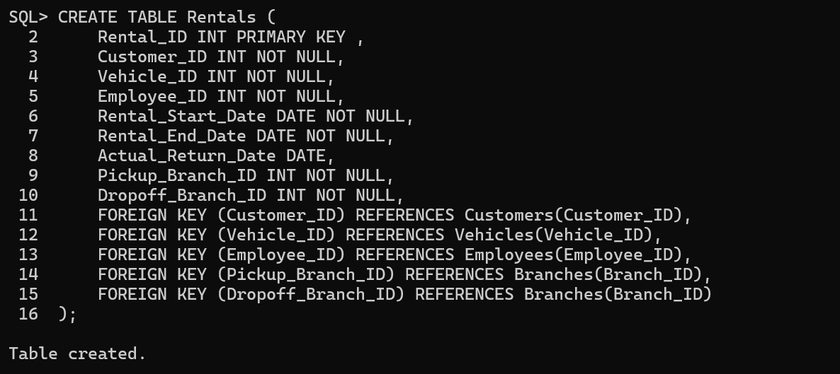

DESCRIBE:

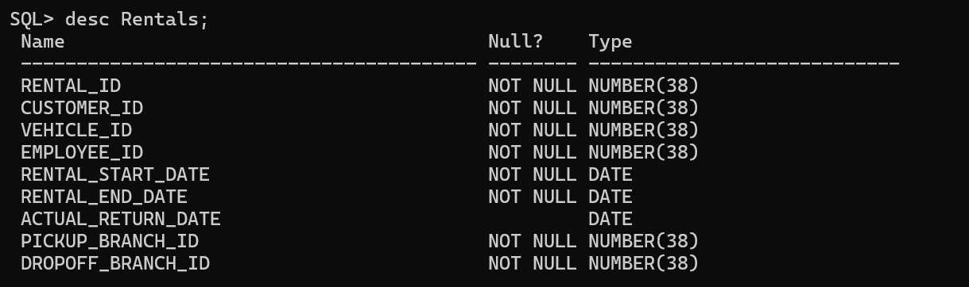

DML SCRIPT:

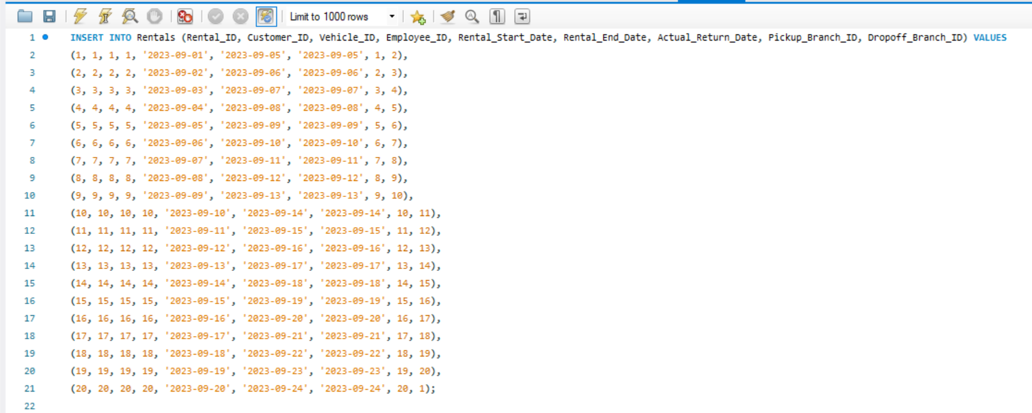

DQL SCRIPT:

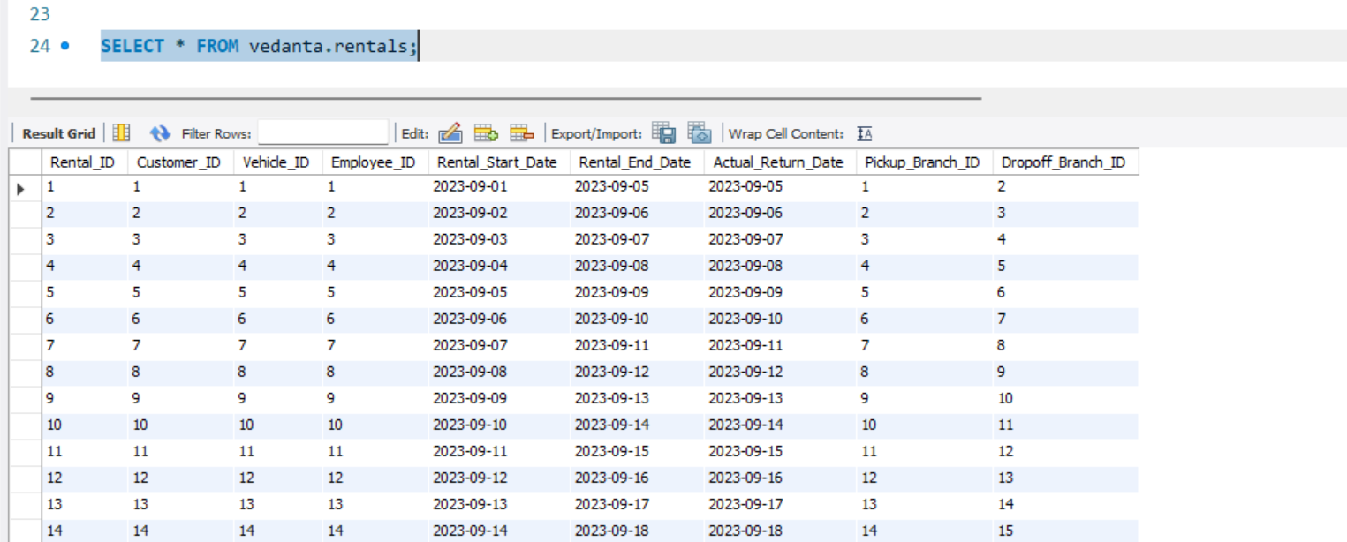

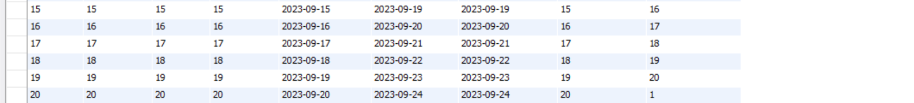

1. **RENTAL_DETAILS:**

It stores information about **Detail_ID, Rental_ID, Daily_Rate, Weekly_Rate, Monthly_Rate, Total_Amount.**

DDL SCRIPT:

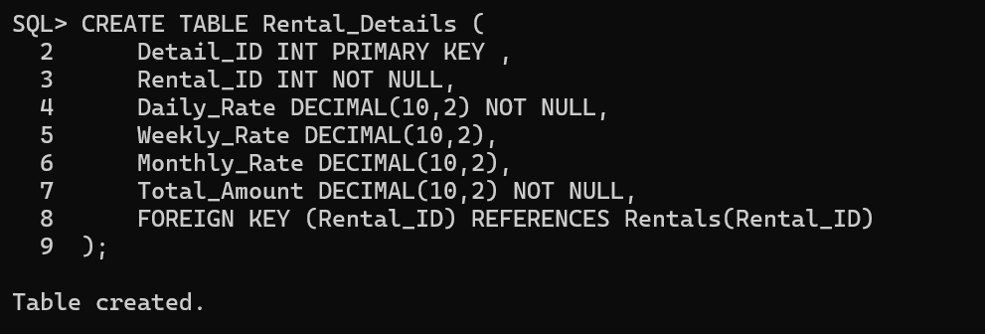

DESCRIBE:

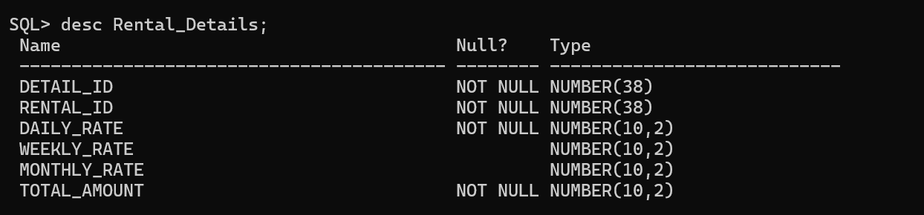

DML SCRIPT:

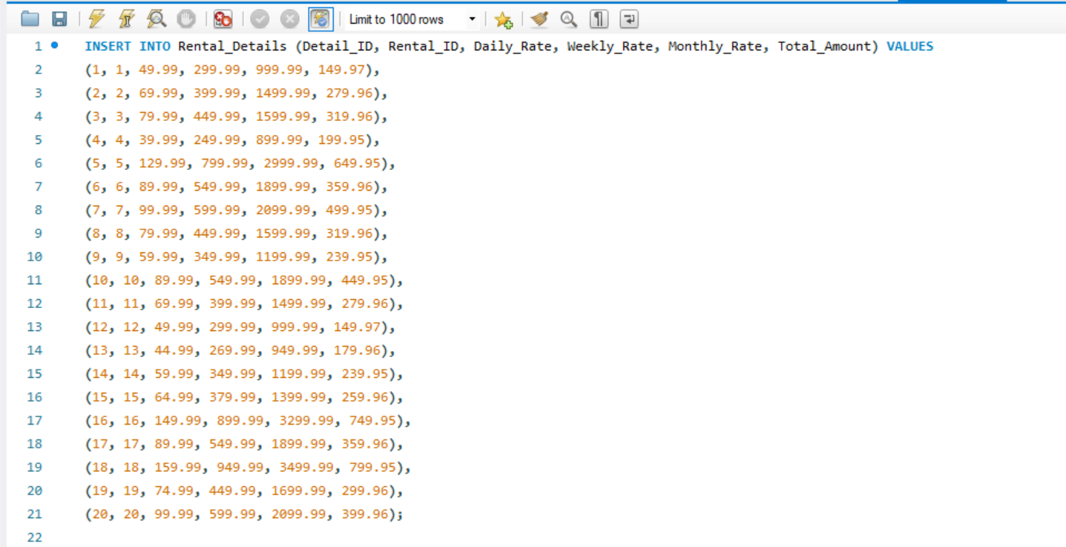

DQL SCRIPT:

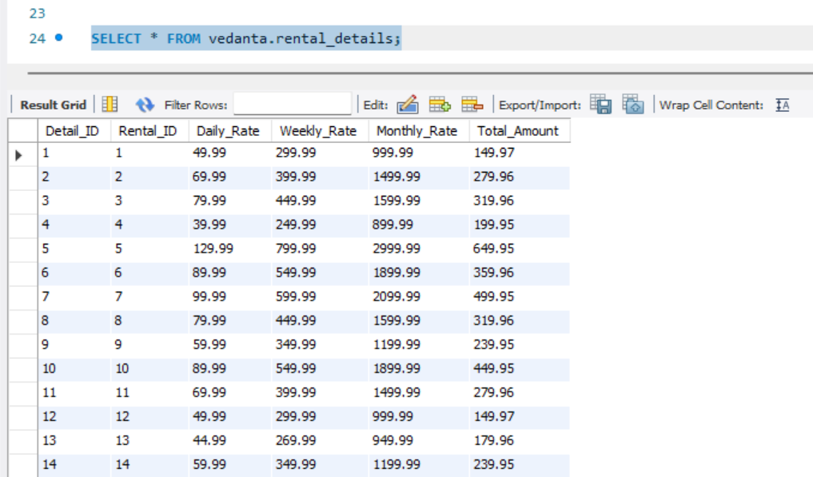

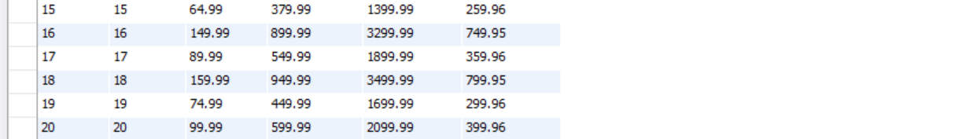

**10. PAYMENTS:**

It stores information about **Payment_ID, Rental_ID, Payment_date,**

**Amount, Payment_method.**

DDL SCRIPT:

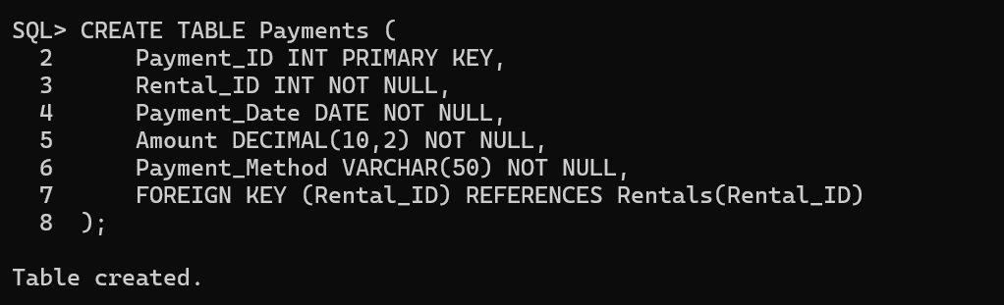

DESCRIBE:

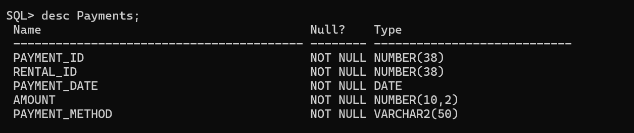

DML SCRIPT:

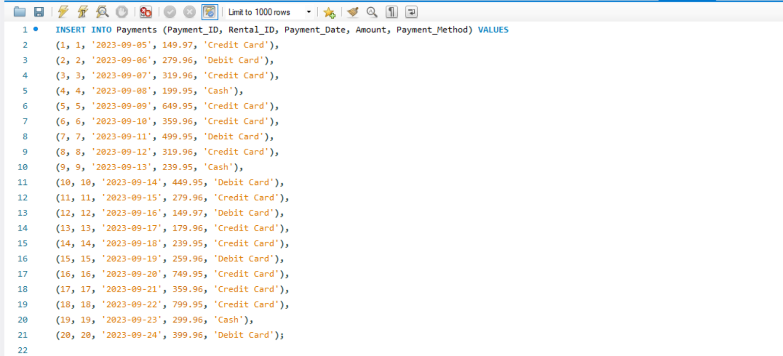

DQL SCRIPT:

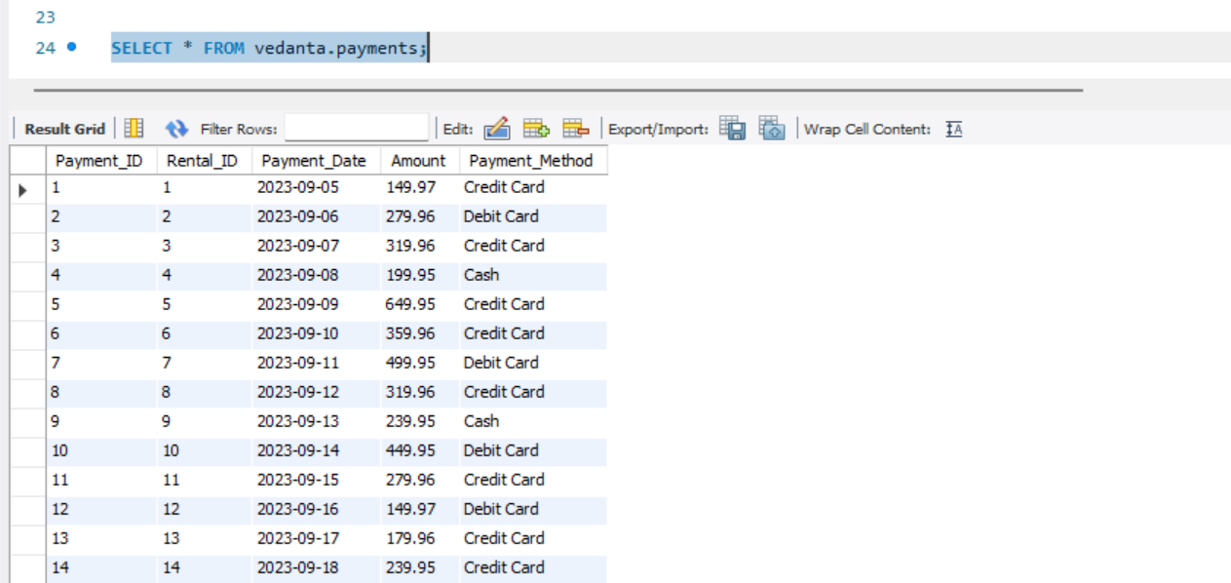

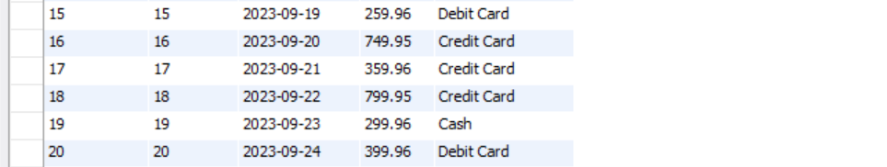

**QUERIES**

1. Retrieve all columns and rows from the specified table.

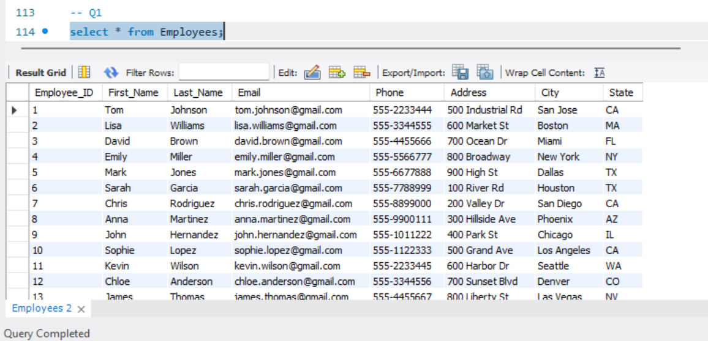

2. Retrieve specific columns from the specified table.

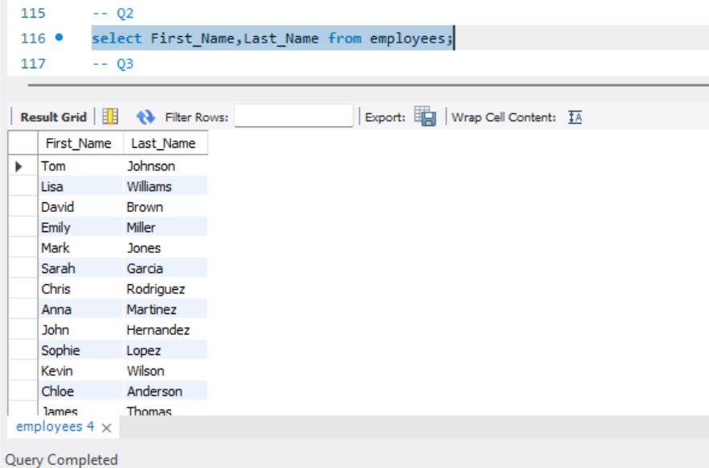

3. Retrieve unique values from a specific column in the table.

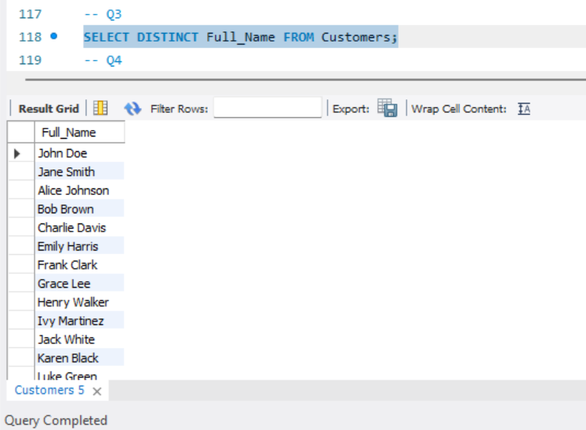

4. Filter rows based on a specified condition in the WHERE clause.

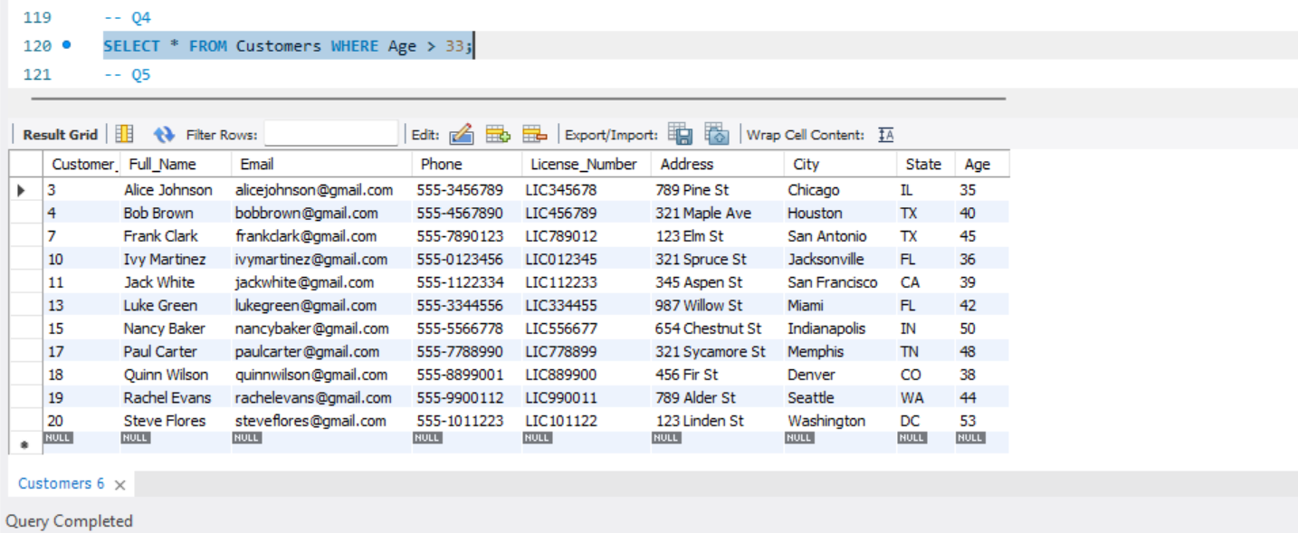

5. Sort the result set in ascending (ASC) or descending (DESC) order based on a specified column.

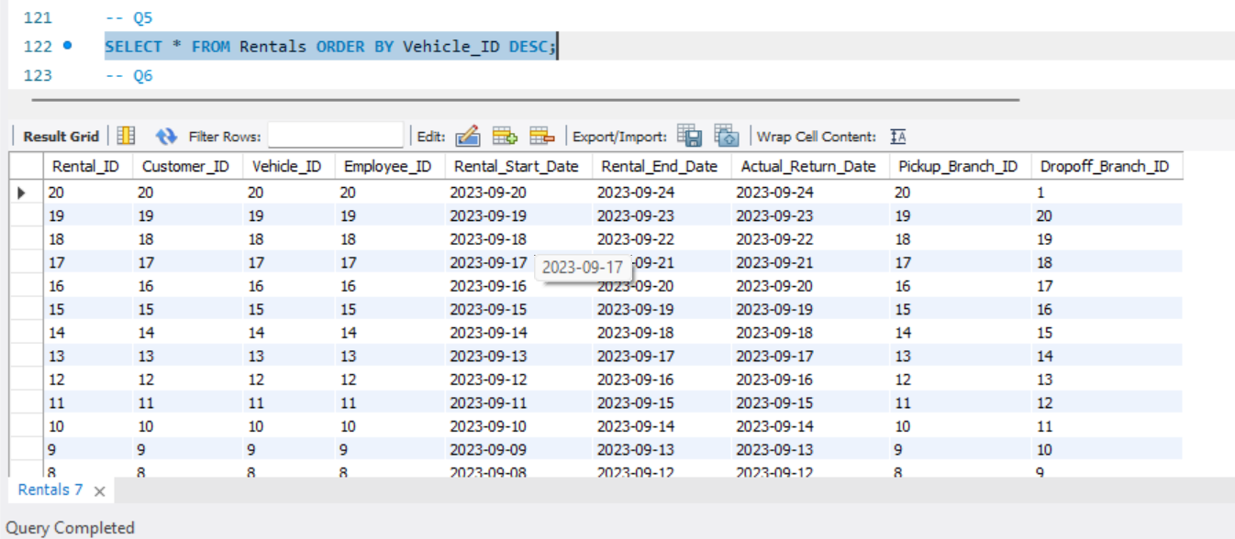

6. Group rows based on the values in a specific column.

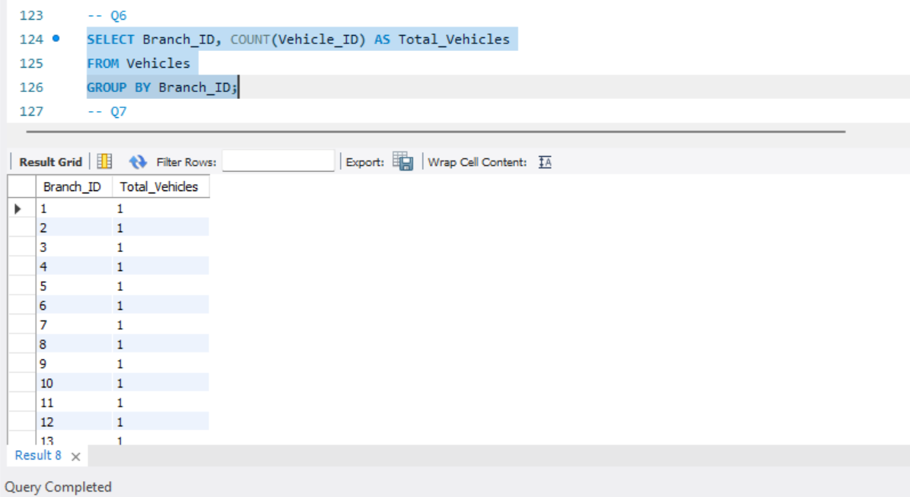

7. Filter groups based on a specified condition in the HAVING clause (used with GROUP BY).

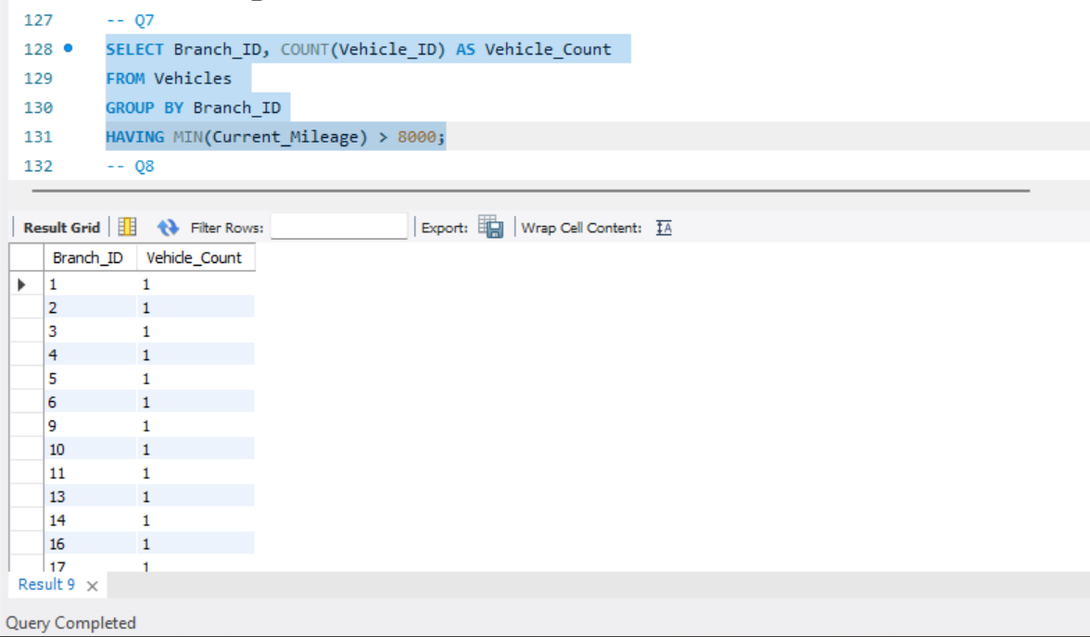

8. Update existing records in a table based on a specified condition.

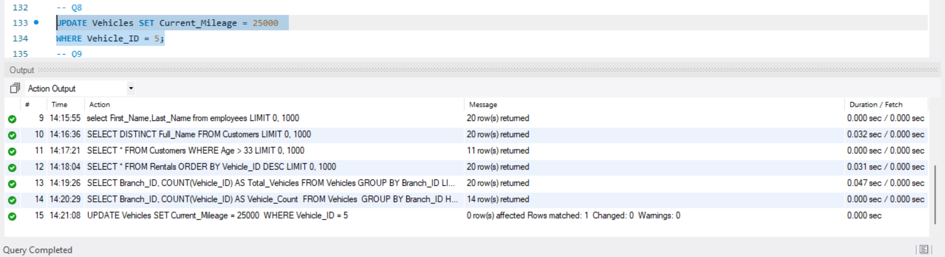

10. Add a new column to an existing table.

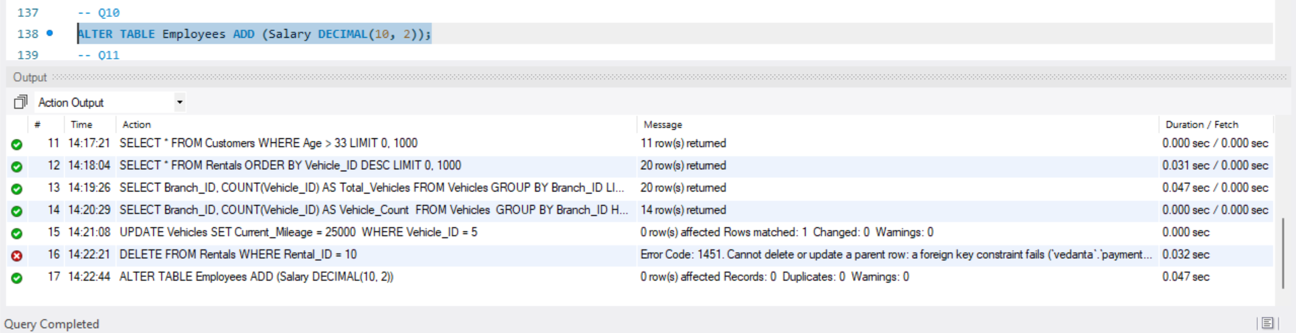

11. Count the number of rows in a table.

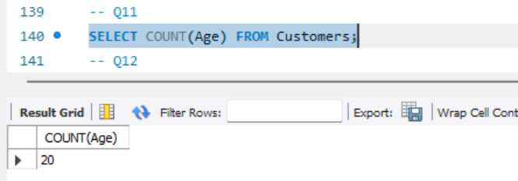

12. Calculate the average value of a numeric column in a table.

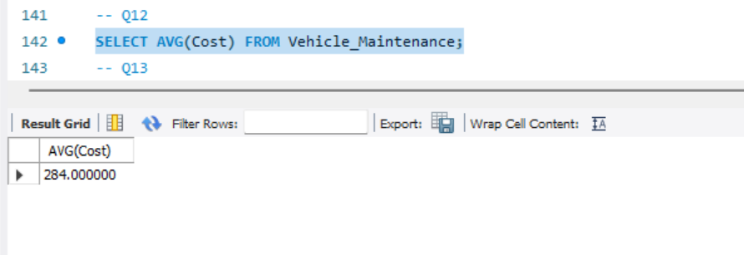

13. Link one table to another – they are attributes in one table which refer to the primary key of another table.

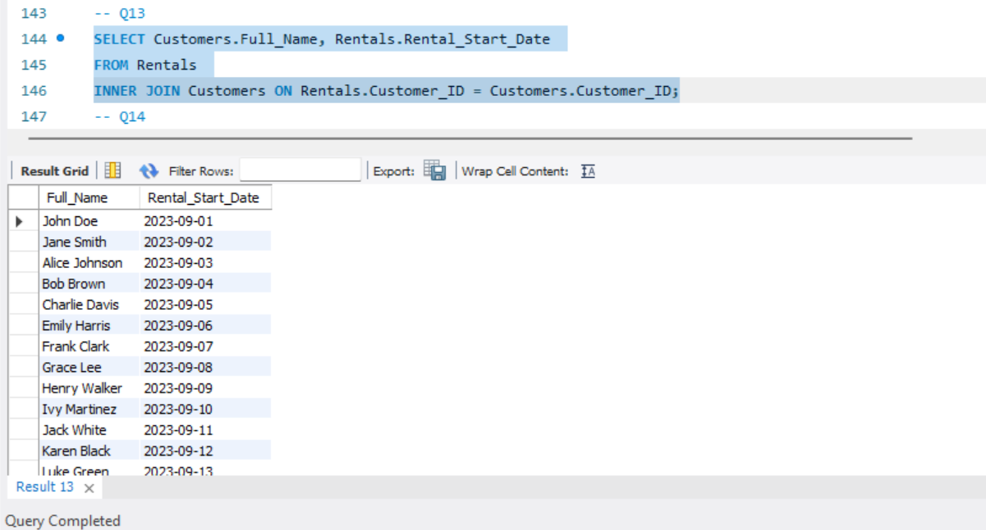

14. return all rows from the customer table where the Customer_name field begins with “H%”:

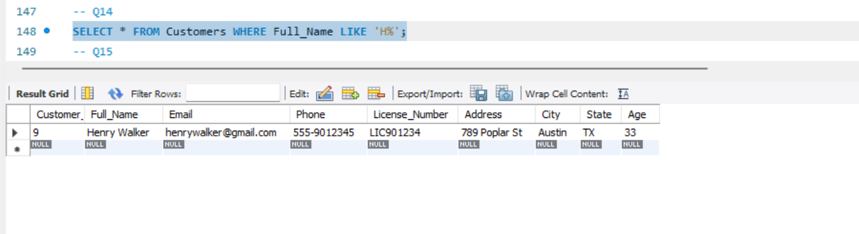

15. fetch a list of all records which have matches in the Customers and Orders tables.

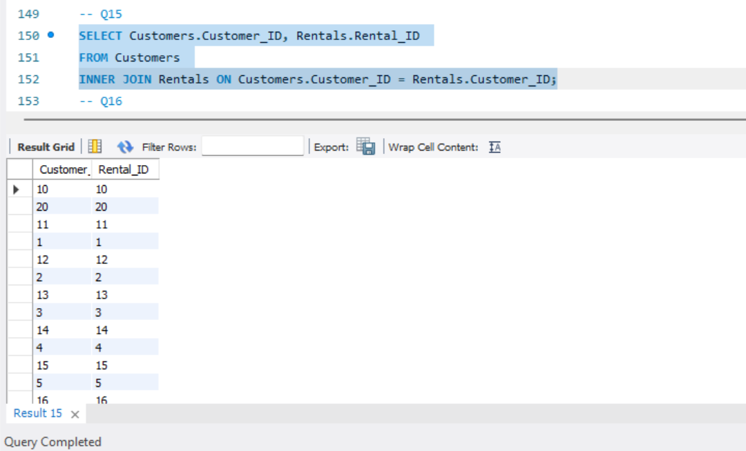

16. Retrive the name of Employee who is taking Maximum salary in Employee table

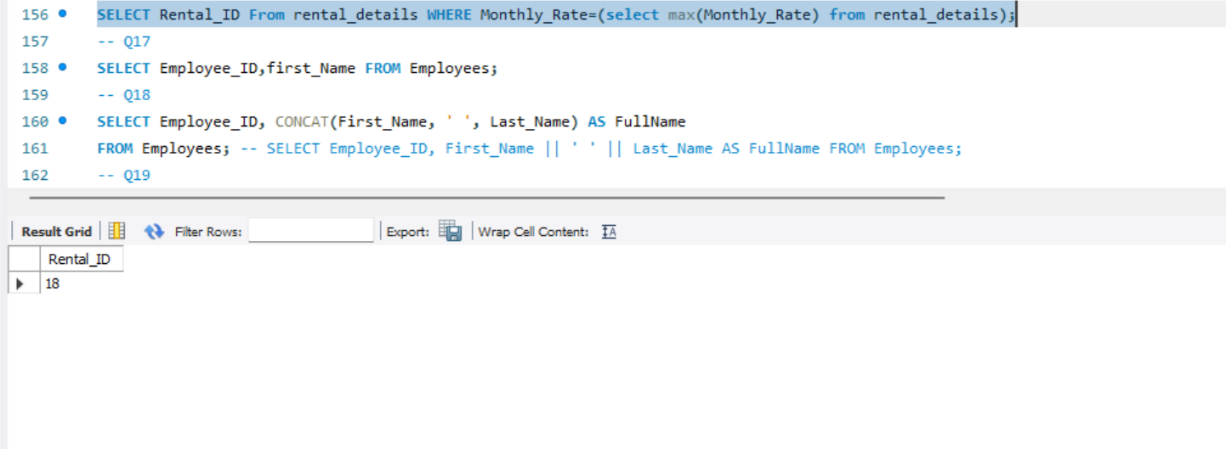

17. selects the records of Employees whose Salary and Name are the same as that of Employees whose ID is 7.

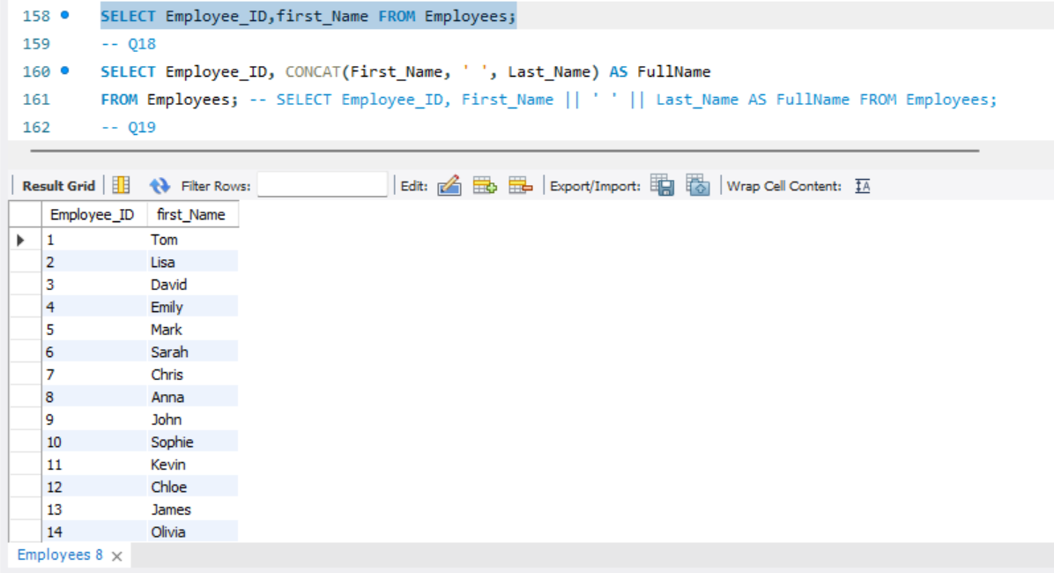

18. combine the First and the Last name columns to create the FullName calculated column.

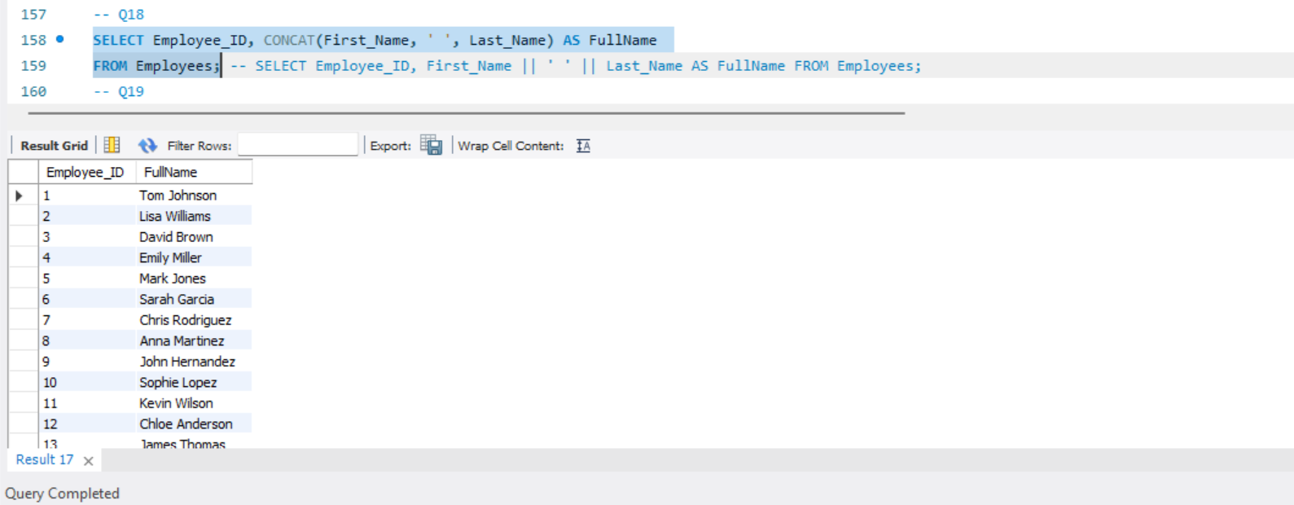

19. creates a CHECK constraint on the “Age” column when the “Persons” table is created. The CHECK constraint ensures that you can not have any person below 18 years.

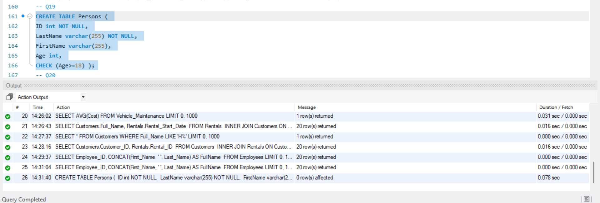

20. Write a query to get the current date.

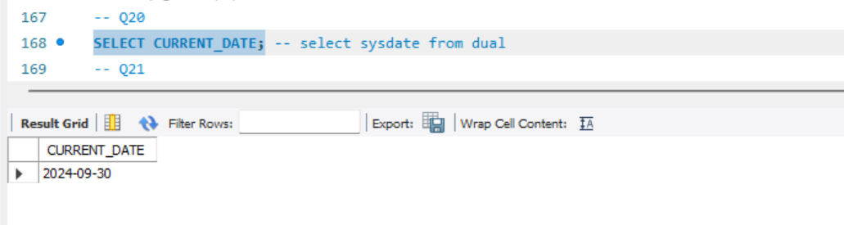

21. retrieve the first four characters of EmpLname from the EmployeeInfo table.

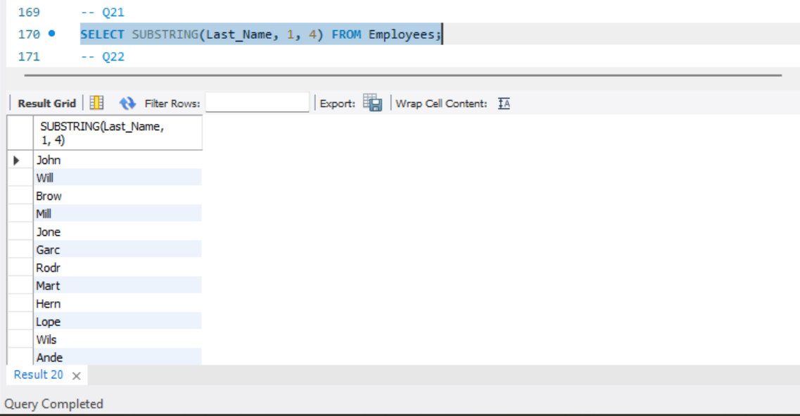

22. create a new table which consists of data and structure copied from the other table.

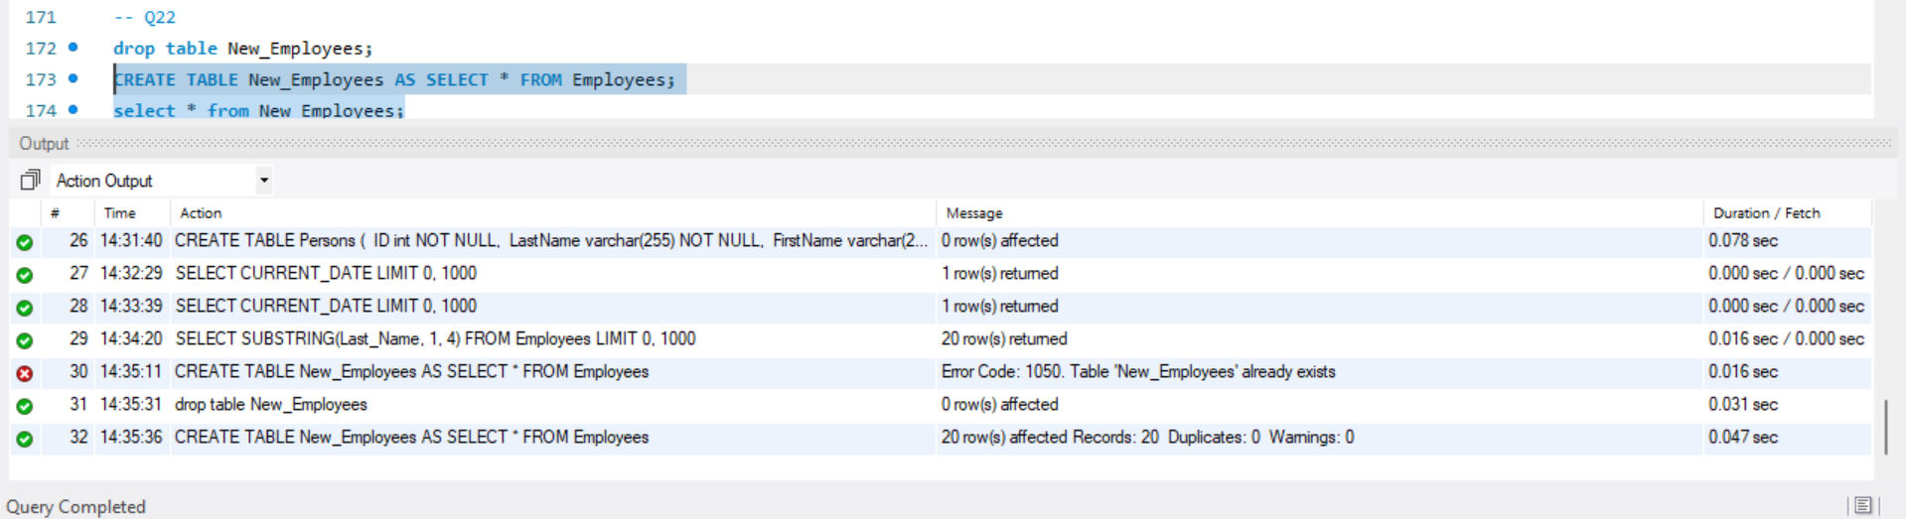

23. find all the employees whose salary is between 50000 to 100000.

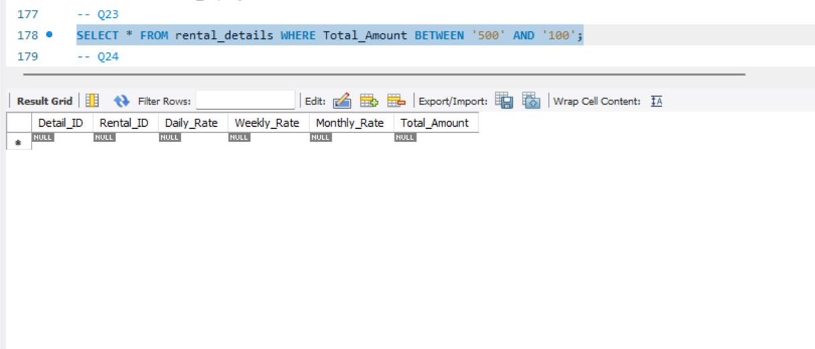

24. fetch details of employees whose EmpLname ends with an alphabet ‘A’ and contains five alphabets.

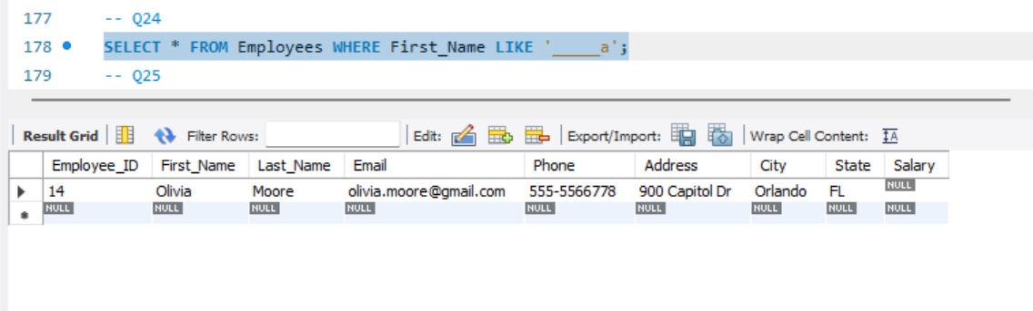

25. Retrieve Employee name who is taking the second highest salary in Employee table

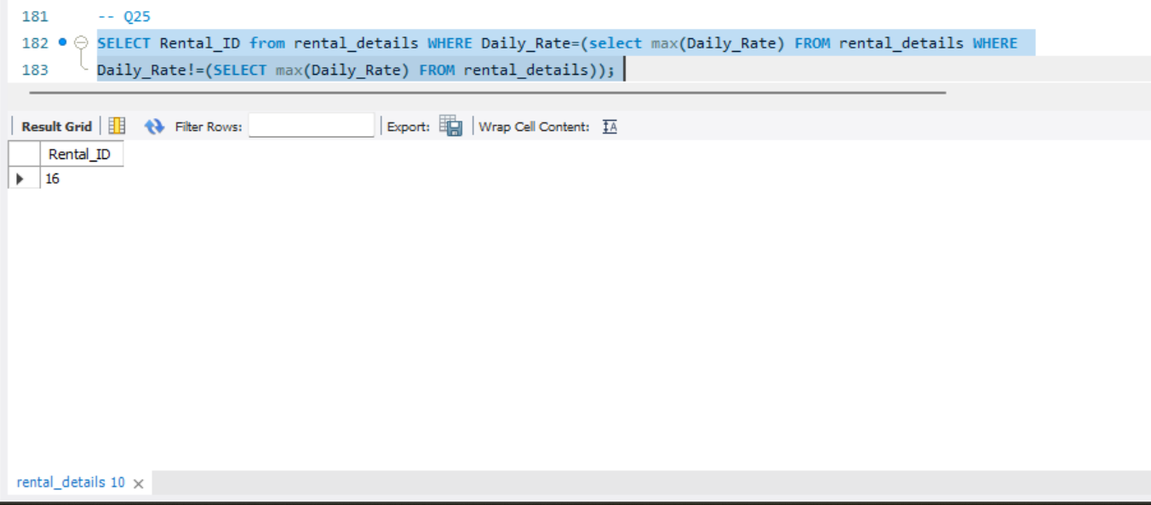

26. Display account number,balance and branch name for such as account table having maximum balance in each branch.

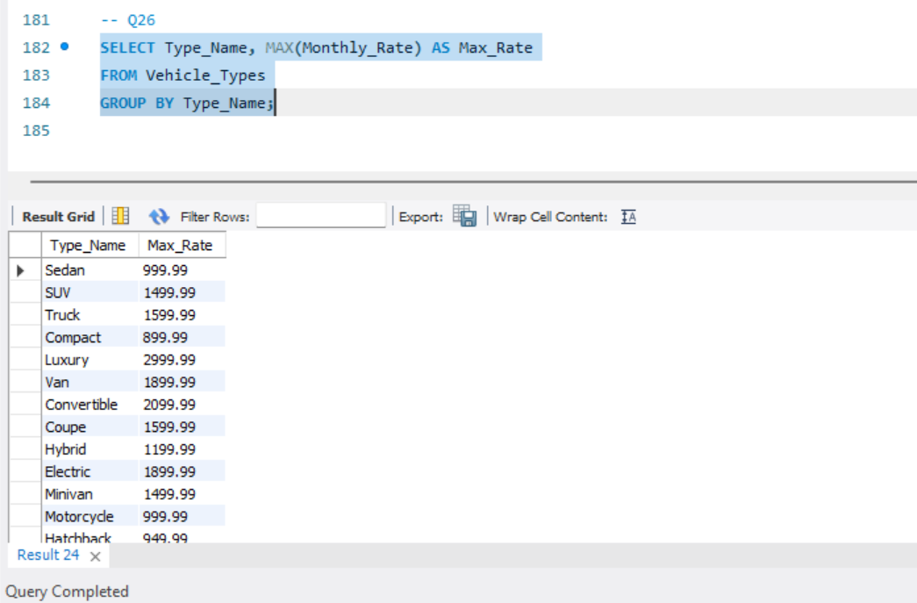

**ER MODEL OF CAR RENTAL SYSTEM**

